1) In sliding puzzle, it consists of a 3x3 grid with eight numbered tiles and one empty space. The goal of the
puzzle is to rearrange the tiles from their initial, scrambled state to a goal state where the numbers are
ordered from 1 to 8, with the empty space in the bottom-right corner. Implement the same using python.
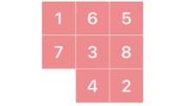

import heapq

# Goal state
GOAL_STATE = ((1, 2, 3),
(4, 5, 6),
(7, 8, 0))

# Possible moves: Up, Down, Left, Right
MOVES = [(-1, 0), (1, 0), (0, -1), (0, 1)]

# Manhattan distance heuristic
def manhattan_distance(state):
distance = 0
for i in range(3):
for j in range(3):
value = state[i][j]
if value != 0:
target_x = (value - 1) // 3
target_y = (value - 1) % 3
distance += abs(target_x - i) + abs(target_y - j)
return distance

# Generate neighbors
def get_neighbors(state):
for i in range(3):
for j in range(3):
if state[i][j] == 0:
x, y = i, j
neighbors = []
for dx, dy in MOVES:
nx, ny = x + dx, y + dy
if 0 <= nx < 3 and 0 <= ny < 3:
new_state = [list(row) for row in state]
new_state[x][y], new_state[nx][ny] = new_state[nx][ny], new_state[x][y]
neighbors.append(tuple(tuple(row) for row in new_state))
return neighbors

# Solve puzzle using A* search
def solve_puzzle(start_state):
start = tuple(tuple(row) for row in start_state)
pq = [(manhattan_distance(start), 0, start)]
visited = set()

while pq:
_, cost, state = heapq.heappop(pq)
if state in visited:
continue
visited.add(state)
if state == GOAL_STATE:
return state
for neighbor in get_neighbors(state):
heapq.heappush(pq, (cost + 1 + manhattan_distance(neighbor), cost + 1, neighbor))
return None

# Print the puzzle state
def print_state(state):
for row in state:
print(' '.join(str(x) if x != 0 else '_' for x in row))
print()

# Take input from user
print("Enter the initial 8-puzzle state (0 for empty tile) row by row, numbers separated by spaces:")
start_state = [list(map(int, input(f"Row {i+1}: ").split())) for i in range(3)]

print("\nInitial State:")
print_state(start_state)

final_state = solve_puzzle(start_state)
if final_state:
print("Final Solved State:")
print_state(final_state)
else:
print("No solution found.")
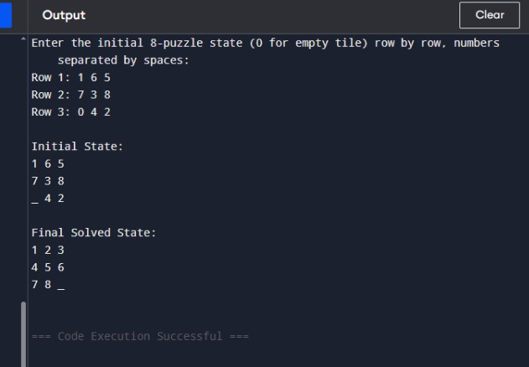

2) The Towers of Hanoi problem involves three pegs (A, B, C) and a number of disks of different sizes that
can slide onto any peg. The puzzle starts with all the disks stacked on one peg in order of decreasing size,
with the largest at the bottom.
The objective of the problem is to move the entire stack to another peg, following these rules:
a) Only one disk can be moved at a time.
b) Each move consists of taking the upper disk from one of the stacks and placing it on top of another
stack.
c) No disk may be placed on top of a smaller disk.
Implement the above Towers of Hanoi problem using Python.
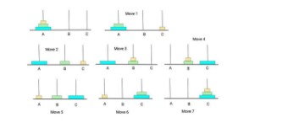
def towers_of_hanoi(n, source, auxiliary, target):
if n == 1:
print(f"Move disk 1 from {source} to {target}")
return
# Move n-1 disks from source to auxiliary peg
towers_of_hanoi(n - 1, source, target, auxiliary)

# Move the remaining disk from source to target
print(f"Move disk {n} from {source} to {target}")

# Move the n-1 disks from auxiliary to target peg
towers_of_hanoi(n - 1, auxiliary, source, target)

# Main Program
num_disks = int(input("Enter the number of disks: "))
print(f"\nSteps to solve Tower of Hanoi with {num_disks} disks:\n")
towers_of_hanoi(num_disks, 'A', 'B', 'C')

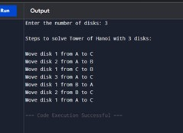
3) Implement a Python program to perform Breadth-First Search (BFS) on a graph. The program should:
• Represent the graph using an adjacency list.
• Start the traversal from a given source node.
• Print the order in which the nodes are visited
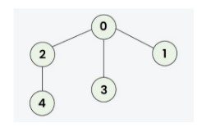
#BFS
from collections import deque

def bfs(graph, start):
visited = []
queue = deque([start])

while queue:
node = queue.popleft()
if node not in visited:
print(node, end=" ")
visited.append(node)
for neighbor in graph.get(node, []):
if neighbor not in visited:
queue.append(neighbor)

# ---- MAIN PROGRAM ----
graph = {}

n = int(input("Enter the number of levels in the graph: "))

print("\nEnter each node and its neighbors.")
print("Example: For node A with neighbors B and C, enter: A B C")
print(" For node 1 with neighbors 2 and 3, enter: 1 2 3\n")

for _ in range(n):
data = input("Enter node and its neighbors: ").split()
node = data[0]
# Convert to int if possible
try:
node = int(node)
except ValueError:
pass

neighbors = []
for val in data[1:]:
try:
neighbors.append(int(val))
except ValueError:
neighbors.append(val)

graph[node] = neighbors

# Display the graph
print("\nGraph (Adjacency List):")
for node, neighbors in graph.items():
print(f"{node} -> {neighbors}")

# BFS Traversal
start = input("\nEnter the starting node: ")
try:
start = int(start)
except ValueError:
pass

if start not in graph:
print("\nInvalid starting node!")
else:
print(f"\nBreadth-First Search traversal starting from node {start}:")
bfs(graph, start)
Sample
Enter the number of levels in the graph: 2

Enter each node and its neighbors.
Example: For node A with neighbors B and C, enter: A B C
For node 1 with neighbors 2 and 3, enter: 1 2 3

Enter node and its neighbors: 0 2 3 1
Enter node and its neighbors: 2 4

Graph (Adjacency List):
0 -> [2, 3, 1]
2 -> [4]

Enter the starting node: 0

Breadth-First Search traversal starting from node 0:
0 2 3 1 4
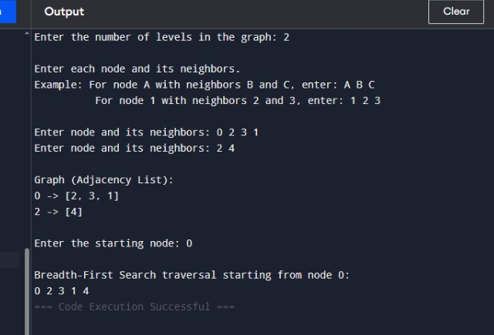
4) The Monkey and Banana problem is a classic artificial intelligence problem where a monkey needs to
navigate through a room to reach a bunch of bananas hanging from the ceiling. The monkey has to move
a box to stand on it to reach the bananas. Implement the above scenario using python.

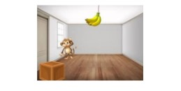
initial_state = {
'monkey': 'A',
'box': 'B',
'monkey_on_box': False,
'has_banana': False
}

goal_state = {
'has_banana': True
}

banana_position = 'C' # Bananas are hanging at position C

def display_state(state):
print(f"Monkey at: {state['monkey']}, Box at: {state['box']}, "
f"On Box: {state['monkey_on_box']}, Has Banana: {state['has_banana']}")

def move(state, position):
state['monkey'] = position
print(f"Monkey moves to {position}")
return state

def push_box(state, position):
if state['monkey'] == state['box']:
state['monkey'] = position
state['box'] = position
print(f"Monkey pushes the box to {position}")
else:
print("Monkey needs to be at the box to push it!")
return state

def climb_box(state):
if state['monkey'] == state['box']:
state['monkey_on_box'] = True
print("Monkey climbs on the box")
else:
print("Monkey must be at the box to climb it!")
return state

def grab_banana(state):
if state['monkey_on_box'] and state['box'] == banana_position:
state['has_banana'] = True
print("Monkey grabs the banana! 🍌")
else:
print("Monkey cannot reach the banana yet.")
return state

# --- Simulation ---
print("Initial State:")
display_state(initial_state)
print("\nActions:")

# Step 1: Move to the box
move(initial_state, 'B')

# Step 2: Push box to bananas
push_box(initial_state, 'C')

# Step 3: Climb onto the box
climb_box(initial_state)

# Step 4: Grab the bananas
grab_banana(initial_state)

# --- Final State ---
print("\nFinal State:")
display_state(initial_state)

if initial_state['has_banana']:
print("\n✅ Goal achieved! Monkey got the bananas!")
else:
print("\n❌ Goal not achieved.")

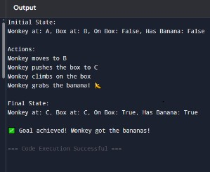
5) Write the python program to place eight queens on an 8 x 8 chessboard in such a way that no two queens
threaten each other. In other words, no two queens can share the same row, column, or diagonal. Use
backtracking to explore different possibilities and ensures that no two queens threaten each other.

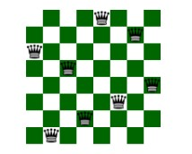
# 8 Queens Problem using Backtracking

N = 8 # Chessboard size (8x8)

def print_solution(board):
"""Display the chessboard with queens placed safely."""
for row in board:
print(" ".join("Q" if x == 1 else "." for x in row))
print("\n")

def is_safe(board, row, col):
"""Check if a queen can be safely placed at board[row][col]."""

# Check this column on upper rows
for i in range(row):
if board[i][col] == 1:
return False

# Check upper left diagonal
for i, j in zip(range(row-1, -1, -1), range(col-1, -1, -1)):
if board[i][j] == 1:
return False

# Check upper right diagonal
for i, j in zip(range(row-1, -1, -1), range(col+1, N)):
if board[i][j] == 1:
return False

return True

def solve_nqueens(board, row):
"""Use backtracking to solve the N Queens problem."""
# Base case: If all queens are placed
if row >= N:
print_solution(board)
return True

success = False
for col in range(N):
if is_safe(board, row, col):
board[row][col] = 1 # Place the queen
success = solve_nqueens(board, row + 1) or success
board[row][col] = 0 # Backtrack (remove the queen)

return success

def solve():
"""Initialize board and trigger solver."""
board = [[0] * N for _ in range(N)]
if not solve_nqueens(board, 0):
print("No solution exists.")
else:
print("All possible solutions found.")

# Run the solver
solve()

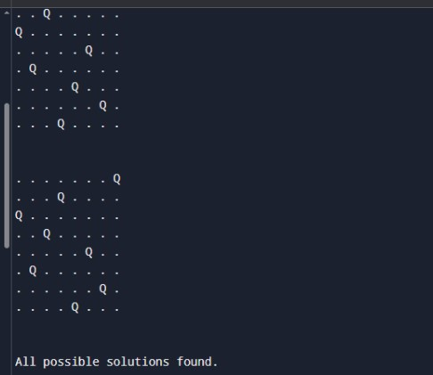
6) Implement a Python program to perform Depth-First Search (DFS) on a graph. The program should:
• Represent the graph using an adjacency list.
• Traverse the graph starting from a given source node.
• Print the order in which the nodes are visited.
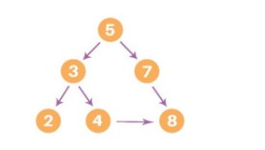
# Depth-First Search (DFS) using adjacency list

def dfs(graph, start, visited=None):
if visited is None:
visited = set()

# Mark the current node as visited
visited.add(start)
print(start, end=" ")

# Recurse for all unvisited neighbors
for neighbor in graph[start]:
if neighbor not in visited:
dfs(graph, neighbor, visited)

# ---------- Main Program ----------
if _name_ == "_main_":
# Representing the graph as an adjacency list (dictionary)
graph = {
'A': ['B', 'C'],
'B': ['D', 'E'],
'C': ['F'],
'D': [],
'E': ['F'],
'F': []
}

start_node = 'A'
print("Depth-First Search starting from node", start_node, ":")
dfs(graph, start_node)
7. Solve the given problem using python. Consider a Water Jug problem: You are given two jugs, a 4-gallon
one and a 3-gallon one. Neither has any measuring marker on it. There is a pump that can be used to fill
the jugs with water. How can you get exactly 2 gallons of water into the 4-gallon jug? Explicit
Assumptions: A jug can be filled from the pump, water can be poured out of a jug onto the ground, water
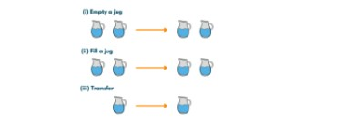
from collections import deque
def water_jug_problem():
jugA, jugB = 4, 3
visited = set()
queue = deque([(0, 0, [])])

while queue:
a, b, path = queue.popleft()
if (a, b) in visited:
continue
visited.add((a, b))
path = path + [(a, b)]
if a == 2:
print("Steps to get exactly 2 gallons in the 4-gallon jug:\n")
for step in path:
print(f"Jug A: {step[0]} gallons, Jug B: {step[1]} gallons")
return

next_states = []
next_states.append((jugA, b))
next_states.append((a, jugB))
next_states.append((0, b))
next_states.append((a, 0))
pour = min(a, jugB - b)
next_states.append((a - pour, b + pour))
pour = min(b, jugA - a)
next_states.append((a + pour, b - pour))

# Add next states to queue
for state in next_states:
if state not in visited:
queue.append((state[0], state[1], path))

print("No solution found.")

water_jug_problem()
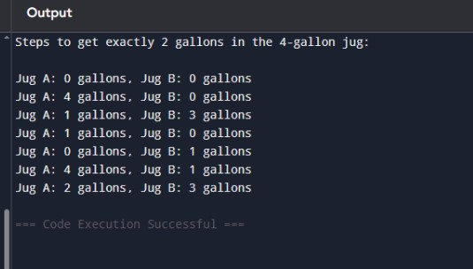
8. Implement a Python program to perform Backward Chaining on a set of Horn clauses. The program
should:
a) Accept a knowledge base defined using Horn clauses (facts and rules).
b) Take a goal (query) as input.
c) Attempt to prove the goal using backward chaining.
d) Print whether the goal can be derived from the knowledge base.

mammal(A) ==> vertebrate(A).
vertebrate(A) ==> animal(A).
vertebrate(A),flying(A) ==> bird(A).
vertebrate("duck").
flying("duck").
mammal("cat").
# ---------------------------
# Knowledge Base
# ---------------------------

# Rules: ("head", ["body1", "body2", ...])
rules = [
("vertebrate(A)", ["mammal(A)"]),
("animal(A)", ["vertebrate(A)"]),
("bird(A)", ["vertebrate(A)", "flying(A)"])
]

# Facts: simple known facts
facts = [
'vertebrate("duck")',
'flying("duck")',
'mammal("cat")'
]

# ---------------------------
# Unification function
# ---------------------------
def unify(term, fact):
"""
Unify a term with a fact.
Returns a substitution dict if successful, else None
"""
if "(" not in term: # simple fact
return {} if term == fact else None

pred1, arg1 = term.split("(")
arg1 = arg1.rstrip(")")
pred2, arg2 = fact.split("(")
arg2 = arg2.rstrip(")")

if pred1 != pred2:
return None

# If term has a variable (uppercase)
if arg1.isupper(): # e.g., A
return {arg1: arg2}
elif arg1 == arg2:
return {}
else:
return None

# ---------------------------
# Backward Chaining Algorithm
# ---------------------------
def backward_chain(goal, facts, rules, visited=None):
if visited is None:
visited = set()

if goal in visited:
return False
visited.add(goal)

# Check if goal is a fact
for fact in facts:
if unify(goal, fact) is not None:
return True

# Check if any rule can derive the goal
for head, body in rules:
substitution = unify(head, goal)
if substitution is not None:
# Apply substitution to body
new_goals = []
for b in body:
if "(" in b:
pred, arg = b.split("(")
arg = arg.rstrip(")")
if arg in substitution:
arg = substitution[arg]
new_goals.append(f"{pred}({arg})")
else:
new_goals.append(b)
# Recursively check all sub-goals
if all(backward_chain(g, facts, rules, visited) for g in new_goals):
return True
return False

# ---------------------------
# Main Program
# ---------------------------
if __name__ == "__main__":
print("Backward Chaining using Horn Clauses\n")
while True:
query = input("Enter the goal to prove (e.g., animal(\"cat\")): ")
result = backward_chain(query, facts, rules)
if result:
print(f"Goal '{query}' can be derived from the knowledge base.\n")
else:
print(f"Goal '{query}' cannot be derived from the knowledge base.\n")

cont = input("Do you want to try another goal? (y/n): ")
if cont.lower() != 'y':
break
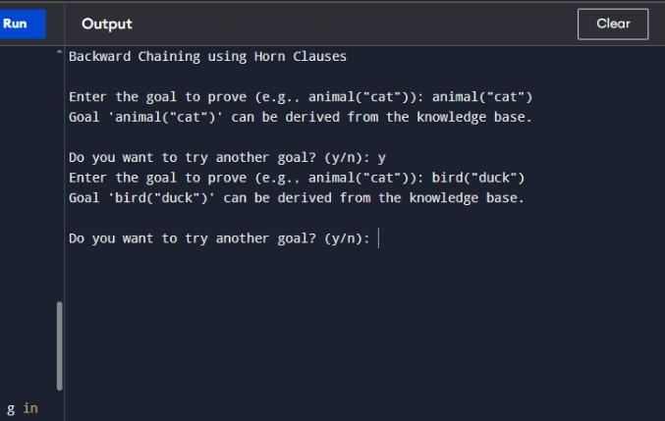
9) Implement a Python program to create a Feedforward Neural Network. The program should:
• Define an input layer, one hidden layer, and an output layer.
• Use activation functions such as Sigmoid or ReLU.
• Perform forward propagation to compute the output values.
• Demonstrate the working of the network on a small sample dataset (e.g., XOR or binary
classification problem).
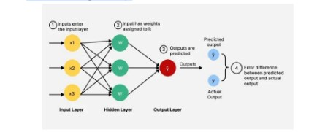
import pygame
import numpy as np

# ---------------- Activation Functions ----------------
def sigmoid(x):
return 1 / (1 + np.exp(-x))

def relu(x):
return np.maximum(0, x)

# ---------------- Feedforward Neural Network ----------------
class FeedforwardNN:
def init(self, input_size, hidden_size, output_size):
self.W1 = np.random.randn(input_size, hidden_size)
self.b1 = np.zeros((1, hidden_size))
self.W2 = np.random.randn(hidden_size, output_size)
self.b2 = np.zeros((1, output_size))

def forward(self, X):
self.z1 = np.dot(X, self.W1) + self.b1
self.a1 = relu(self.z1)
self.z2 = np.dot(self.a1, self.W2) + self.b2
self.a2 = sigmoid(self.z2)
return self.a2

# ---------------- Pygame Visualization ----------------
pygame.init()
WIDTH, HEIGHT = 600, 400
WIN = pygame.display.set_mode((WIDTH, HEIGHT))
pygame.display.set_caption("Feedforward Neural Network Visualization")

FONT = pygame.font.SysFont("Arial", 20)
WHITE = (255, 255, 255)
BLACK = (0, 0, 0)
BLUE = (50, 100, 255)
GREEN = (50, 255, 100)

def draw_network(nn, X, outputs):
WIN.fill(WHITE)

# Layer positions
layers = [len(X[0]), len(nn.a1[0]), len(nn.a2[0])]
x_spacing = WIDTH // (len(layers) + 1)

positions = []
for i, num_nodes in enumerate(layers):
y_spacing = HEIGHT // (num_nodes + 1)
layer_pos = []
for j in range(num_nodes):
pos = (x_spacing*(i+1), y_spacing*(j+1))
layer_pos.append(pos)
pygame.draw.circle(WIN, BLUE, pos, 25)
positions.append(layer_pos)

# Draw connections
for i in range(len(layers)-1):
for j, (x1, y1) in enumerate(positions[i]):
for k, (x2, y2) in enumerate(positions[i+1]):
pygame.draw.line(WIN, BLACK, (x1, y1), (x2, y2), 2)

# Draw outputs on neurons
for i, layer in enumerate(positions):
for j, (x, y) in enumerate(layer):
if i == 0:
val = X[0][j] # first input for visualization
elif i == 1:
val = nn.a1[0][j]
else:
val = outputs[0][j]
text = FONT.render(f"{val:.2f}", True, GREEN)
WIN.blit(text, (x-20, y-10))

pygame.display.update()

def main():
clock = pygame.time.Clock()
nn = FeedforwardNN(input_size=2, hidden_size=2, output_size=1)

# XOR input
X = np.array([[0,1]])

outputs = nn.forward(X)

running = True
while running:
clock.tick(30)
for event in pygame.event.get():
if event.type == pygame.QUIT:
running = False

draw_network(nn, X, outputs)

pygame.quit()

if name == "main":
main()
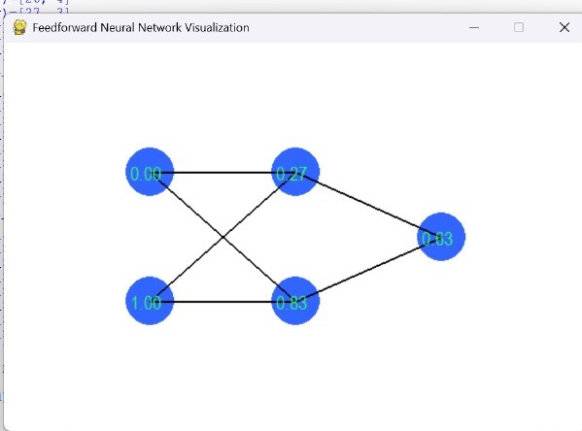
10. Implement a Python program for a Checkers AI agent using the Minimax algorithm with Alpha–Beta
pruning. The program should:
a) Represent the Checkers board and its legal moves.
b) Allow two players (Human vs AI) or (AI vs AI) to play.
c) Use Minimax with Alpha–Beta pruning for the AI’s decision-making.
d) Display the board after every move and declare the winner at the end.
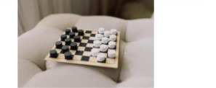

import math
import copy

EMPTY = '.'
PLAYER_PIECE = 'P'
AI_PIECE = 'A'
BOARD_SIZE = 8

def create_board():
board = [[EMPTY for _ in range(BOARD_SIZE)] for _ in range(BOARD_SIZE)]
for row in range(3):
for col in range(BOARD_SIZE):
if (row + col) % 2 == 1:
board[row][col] = AI_PIECE
for row in range(5, 8):
for col in range(BOARD_SIZE):
if (row + col) % 2 == 1:
board[row][col] = PLAYER_PIECE
return board

def print_board(board):
print(" " + " ".join(map(str, range(BOARD_SIZE))))
for i in range(BOARD_SIZE):
print(i, " ".join(board[i]))
print()

def get_all_moves(board, piece):
moves = []
for r in range(BOARD_SIZE):
for c in range(BOARD_SIZE):
if board[r][c] == piece:
moves.extend(get_valid_moves(board, r, c, piece))
return moves

def get_valid_moves(board, r, c, piece):
moves = []
directions = [(-1, -1), (-1, 1)] if piece == PLAYER_PIECE else [(1, -1), (1, 1)]
for dr, dc in directions:
new_r, new_c = r + dr, c + dc
if 0 <= new_r < BOARD_SIZE and 0 <= new_c < BOARD_SIZE:
if board[new_r][new_c] == EMPTY:
moves.append(((r, c), (new_r, new_c)))
elif board[new_r][new_c] != piece:
jump_r, jump_c = new_r + dr, new_c + dc
if 0 <= jump_r < BOARD_SIZE and 0 <= jump_c < BOARD_SIZE and board[jump_r][jump_c] == EMPTY:
moves.append(((r, c), (jump_r, jump_c)))
return moves

def make_move(board, move):
new_board = copy.deepcopy(board)
(r1, c1), (r2, c2) = move
piece = new_board[r1][c1]
new_board[r1][c1] = EMPTY
new_board[r2][c2] = piece

if abs(r2 - r1) == 2:
jumped_r = (r1 + r2) // 2
jumped_c = (c1 + c2) // 2
new_board[jumped_r][jumped_c] = EMPTY
return new_board

def evaluate(board):
player_score = sum(row.count(PLAYER_PIECE) for row in board)
ai_score = sum(row.count(AI_PIECE) for row in board)
return ai_score - player_score

def minimax(board, depth, alpha, beta, maximizing_player):
if depth == 0 or is_game_over(board):
return evaluate(board), board

if maximizing_player:
max_eval = -math.inf
best_move = None
for move in get_all_moves(board, AI_PIECE):
eval_val, _ = minimax(make_move(board, move), depth - 1, alpha, beta, False)
if eval_val > max_eval:
max_eval = eval_val
best_move = move
alpha = max(alpha, eval_val)
if beta <= alpha:
break
return max_eval, make_move(board, best_move) if best_move else board

else:
min_eval = math.inf
best_move = None
for move in get_all_moves(board, PLAYER_PIECE):
eval_val, _ = minimax(make_move(board, move), depth - 1, alpha, beta, True)
if eval_val < min_eval:
min_eval = eval_val
best_move = move
beta = min(beta, eval_val)
if beta <= alpha:
break
return min_eval, make_move(board, best_move) if best_move else board

def is_game_over(board):
return not get_all_moves(board, PLAYER_PIECE) or not get_all_moves(board, AI_PIECE)

def get_winner(board):
player_pieces = sum(row.count(PLAYER_PIECE) for row in board)
ai_pieces = sum(row.count(AI_PIECE) for row in board)
if player_pieces > ai_pieces:
return "Human Wins!"
elif ai_pieces > player_pieces:
return "AI Wins!"
else:
return "Draw!"

def play_game():
board = create_board()
print("Welcome to Checkers AI!")
mode = input("Choose mode: 1) Human vs AI 2) AI vs AI : ")

print_board(board)
turn = 'PLAYER'

while not is_game_over(board):
if turn == 'PLAYER':
if mode == '1':
moves = get_all_moves(board, PLAYER_PIECE)
if not moves:
break
print("Your available moves:")
for i, move in enumerate(moves):
print(f"{i}: {move}")
choice = int(input("Choose your move: "))
board = make_move(board, moves[choice])
else:
_, board = minimax(board, 3, -math.inf, math.inf, False)
turn = 'AI'

else:
print("AI is thinking...")
_, board = minimax(board, 3, -math.inf, math.inf, True)
turn = 'PLAYER'

print_board(board)

print("Game Over! " + get_winner(board))

if _name_ == "_main_":
play_game()

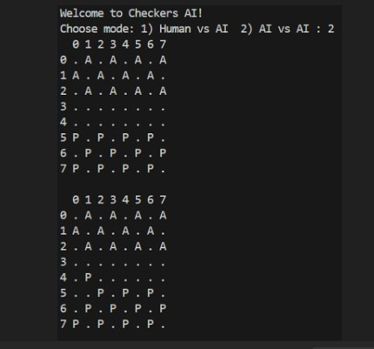
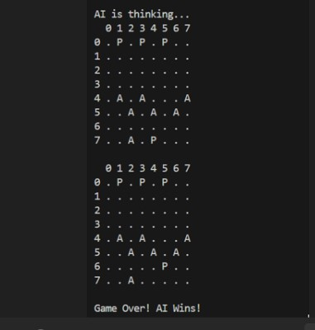
11. Implement a Python program to build and evaluate a Decision Tree classifier.
The program should :
a) Take a dataset as input from the given figure.
b) Build the Decision Tree using a splitting criterion.
c) Display the tree structure in a readable form (rules or indented hierarchy).
d) Classify new instances based on the trained tree.
e) Print the accuracy of the model on test data.
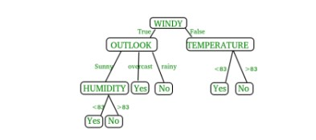
dataset = [
['Sunny', 'Hot', 'High', 'False', 'No'],
['Sunny', 'Hot', 'High', 'True', 'No'],
['Overcast', 'Hot', 'High', 'False', 'Yes'],
['Rainy', 'Mild', 'High', 'False', 'Yes'],
['Rainy', 'Cool', 'Normal', 'False', 'Yes'],
['Rainy', 'Cool', 'Normal', 'True', 'No'],
['Overcast', 'Cool', 'Normal', 'True', 'Yes'],
['Sunny', 'Mild', 'High', 'False', 'No'],
['Sunny', 'Cool', 'Normal', 'False', 'Yes'],
['Rainy', 'Mild', 'Normal', 'False', 'Yes'],
['Sunny', 'Mild', 'Normal', 'True', 'Yes'],
['Overcast', 'Mild', 'High', 'True', 'Yes'],
['Overcast', 'Hot', 'Normal', 'False', 'Yes'],
['Rainy', 'Mild', 'High', 'True', 'No']
]

# Step 2: Define feature names
features = ['Outlook', 'Temperature', 'Humidity', 'Windy']

# Step 3: Function to calculate entropy
import math
def entropy(rows):
total = len(rows)
yes = len([r for r in rows if r[-1] == 'Yes'])
no = total - yes
if yes == 0 or no == 0:
return 0
p1 = yes / total
p2 = no / total
return -p1 * math.log2(p1) - p2 * math.log2(p2)

# Step 4: Function to split dataset
def split_dataset(rows, column, value):
set1 = [r for r in rows if r[column] == value]
set2 = [r for r in rows if r[column] != value]
return (set1, set2)

# Step 5: Choose the best split
def best_split(rows):
best_gain = 0
best_column = None
best_value = None
current_entropy = entropy(rows)
n_features = len(rows[0]) - 1

for col in range(n_features):
values = set([r[col] for r in rows])
for v in values:
set1, set2 = split_dataset(rows, col, v)
if len(set1) == 0 or len(set2) == 0:
continue
p = len(set1) / len(rows)
gain = current_entropy - p * entropy(set1) - (1 - p) * entropy(set2)
if gain > best_gain:
best_gain = gain
best_column = col
best_value = v
return best_gain, best_column, best_value

# Step 6: Define the Decision Tree structure
class DecisionNode:
def _init_(self, column=None, value=None, true_branch=None, false_branch=None, result=None):
self.column = column
self.value = value
self.true_branch = true_branch
self.false_branch = false_branch
self.result = result

# Step 7: Build the tree recursively
def build_tree(rows):
gain, column, value = best_split(rows)
if gain == 0:
yes = len([r for r in rows if r[-1] == 'Yes'])
no = len(rows) - yes
return DecisionNode(result='Yes' if yes >= no else 'No')
set1, set2 = split_dataset(rows, column, value)
true_branch = build_tree(set1)
false_branch = build_tree(set2)
return DecisionNode(column, value, true_branch, false_branch)

# Step 8: Print tree (readable format)
def print_tree(node, spacing=""):
if node.result is not None:
print(spacing + "Predict:", node.result)
return
print(f"{spacing}{features[node.column]} == {node.value}?")
print(spacing + '--> True:')
print_tree(node.true_branch, spacing + " ")
print(spacing + '--> False:')
print_tree(node.false_branch, spacing + " ")

# Step 9: Classify new instances
def classify(observation, node):
if node.result is not None:
return node.result
if observation[node.column] == node.value:
return classify(observation, node.true_branch)
else:
return classify(observation, node.false_branch)

# Step 10: Build and test
tree = build_tree(dataset)

print("\n=== Decision Tree Structure ===")
print_tree(tree)

# Test data
test_data = ['Rainy', 'Mild', 'Normal', 'False'] # Expected Yes
prediction = classify(test_data, tree)
print("\nPrediction for", test_data, "->", prediction)
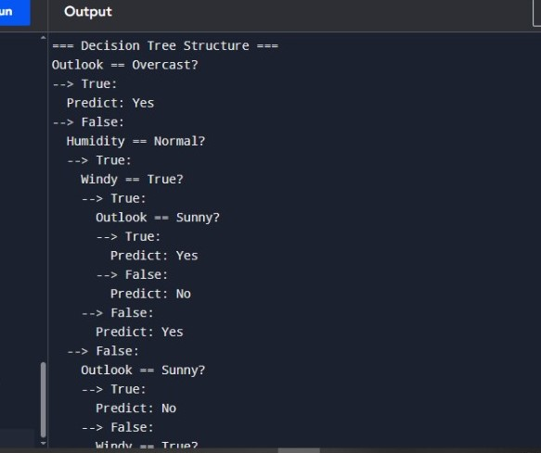
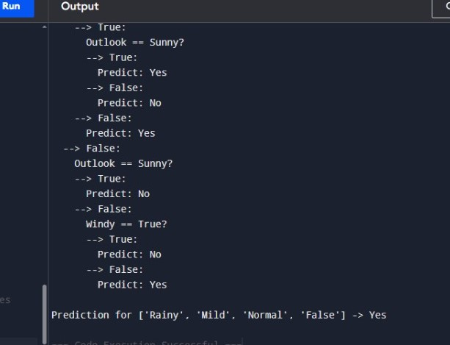
12. It's a river-crossing puzzle that involves three missionaries and three cannibals who need to cross a river
from one side to another. The problem comes with certain constraints:
a) There is a boat that can carry at most two people at a time.
b) On either side of the river, if the number of cannibals ever exceeds the number of missionaries, the
cannibals will eat the missionaries, and the mission will fail.
c) The goal is to find a series of moves that allow all the missionaries and cannibals to cross the river
safely. Implement the scenario using Python.
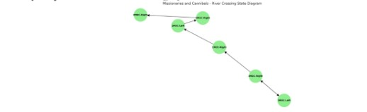
from collections import deque
start_state = (3, 3, 'left')
goal_state = (0, 0, 'right')
def is_valid_state(m_left, c_left, boat_pos):
m_right = 3 - m_left
c_right = 3 - c_left
if not (0 <= m_left <= 3 and 0 <= c_left <= 3):
return False
if (m_left > 0 and m_left < c_left) or (m_right > 0 and m_right < c_right):
return False
return True
def get_successors(state):
m_left, c_left, boat_pos = state
successors = []
moves = [(1, 0), (2, 0), (0, 1), (0, 2), (1, 1)]

for m_move, c_move in moves:
if boat_pos == 'left':
new_state = (m_left - m_move, c_left - c_move, 'right')
else:
new_state = (m_left + m_move, c_left + c_move, 'left')

if is_valid_state(*new_state):
successors.append(new_state)

return successors

# BFS to find the shortest path
def bfs(start, goal):
queue = deque([(start, [start])])
visited = set()

while queue:
current_state, path = queue.popleft()

if current_state == goal:
return path

visited.add(current_state)

for next_state in get_successors(current_state):
if next_state not in visited:
queue.append((next_state, path + [next_state]))

return None

# Run the BFS search
solution = bfs(start_state, goal_state)

# Print the solution
if solution:
print("Solution found! Sequence of states:")
for step in solution:
print(step)
else:
print("No solution found.")
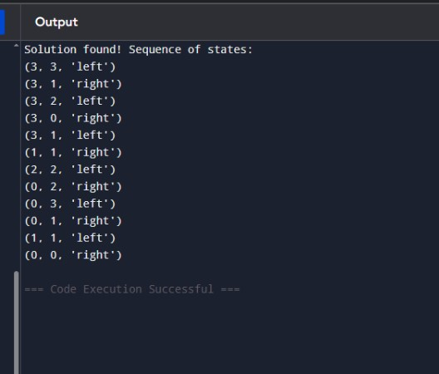

13. Implement a Python program to simulate the Tic Tac Toe game. The program should:
a) Represent the 3×3 game board.
b) Allow a human player to play against an AI player.
c) Print the board after each move.
d) Declare the winner or draw at the end of the game
import random

def print_board(board):
for row in board:
print(" | ".join(row))
print("-" * 9)

def check_winner(board, player):
# Check rows, columns, and diagonals for a win
for i in range(3):
if all(board[i][j] == player for j in range(3)): # row
return True
if all(board[j][i] == player for j in range(3)): # column
return True
if all(board[i][i] == player for i in range(3)): # main diagonal
return True
if all(board[i][2 - i] == player for i in range(3)): # anti-diagonal
return True
return False

def board_full(board):
return all(board[i][j] != ' ' for i in range(3) for j in range(3))

def human_move(board):
while True:
try:
move = input("Enter your move as row and column (0, 1, or 2) separated by space: ")
row, col = map(int, move.split())
if row in range(3) and col in range(3) and board[row][col] == ' ':
board[row][col] = 'X'
break
else:
print("Invalid move, cell already occupied or out of bounds.")
except:
print("Invalid input. Please enter two numbers separated by space.")

def ai_move(board):
# Simple AI: random available cell
available = [(i, j) for i in range(3) for j in range(3) if board[i][j] == ' ']
if available:
row, col = random.choice(available)
board[row][col] = 'O'

def tic_tac_toe():
board = [[' ' for _ in range(3)] for _ in range(3)]
print_board(board)

while True:
human_move(board)
print_board(board)
if check_winner(board, 'X'):
print("Human wins!")
break
if board_full(board):
print("It's a draw!")
break

ai_move(board)
print("AI's move:")
print_board(board)
if check_winner(board, 'O'):
print("AI wins!")
break
if board_full(board):
print("It's a draw!")
break

if __name__ == "main":
tic_tac_toe()
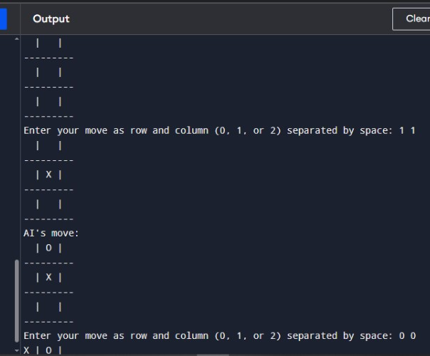
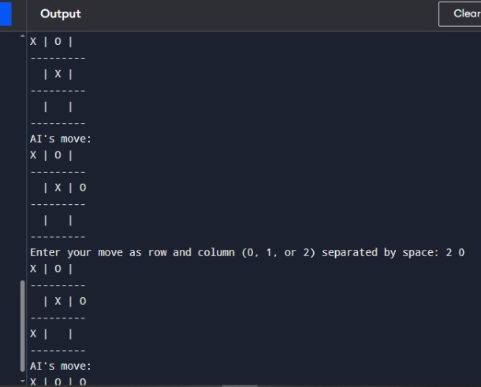
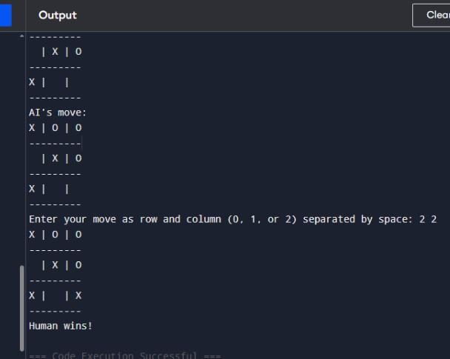
14. Imagine you have a simple autonomous vacuum cleaner, which can move around in a grid-based
environment. The grid is divided into cells, some of which are dirty, and some are clean. The vacuum
cleaner can move in four directions: up, down, left, and right. Its primary task is to clean all the dirty cells
while minimizing its movements. Implement the above AI problem using python.
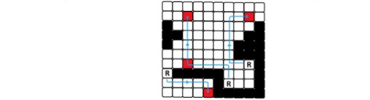
import pygame
import random
import sys

# Initialize pygame
pygame.init()

# Grid setup
ROWS, COLS = 5, 5
CELL_SIZE = 100
WIDTH, HEIGHT = COLS * CELL_SIZE, ROWS * CELL_SIZE
FPS = 10

# Colors
WHITE = (240, 240, 240)
BLACK = (0, 0, 0)
GREEN = (0, 200, 0)
BROWN = (139, 69, 19)
BLUE = (0, 120, 255)
GRAY = (180, 180, 180)

# Initialize window
screen = pygame.display.set_mode((WIDTH, HEIGHT + 80))
pygame.display.set_caption("🧹 Autonomous Vacuum Cleaner Game")

font = pygame.font.SysFont("arial", 24)

# Initialize grid with random dirty cells
grid = [['.' for _ in range(COLS)] for _ in range(ROWS)]
num_dirty = random.randint(5, 8)
dirty_cells = random.sample([(r, c) for r in range(ROWS) for c in range(COLS)], num_dirty)
for r, c in dirty_cells:
grid[r][c] = 'D'

# Place vacuum at random position
vacuum_r, vacuum_c = random.choice([(r, c) for r in range(ROWS) for c in range(COLS)])
grid[vacuum_r][vacuum_c] = 'V'

moves = 0

def draw_grid():
"""Draws the game grid and elements."""
for r in range(ROWS):
for c in range(COLS):
x, y = c * CELL_SIZE, r * CELL_SIZE
pygame.draw.rect(screen, GRAY, (x, y, CELL_SIZE, CELL_SIZE), 1)

if grid[r][c] == 'D':
pygame.draw.circle(screen, BROWN, (x + CELL_SIZE//2, y + CELL_SIZE//2), 20)
elif grid[r][c] == 'V':
pygame.draw.rect(screen, BLUE, (x + 25, y + 25, 50, 50), border_radius=10)

# Draw text area
pygame.draw.rect(screen, WHITE, (0, HEIGHT, WIDTH, 80))
dirty_count = sum(row.count('D') for row in grid)
text1 = font.render(f"Dirty Cells Left: {dirty_count}", True, BLACK)
text2 = font.render(f"Moves Taken: {moves}", True, BLACK)
screen.blit(text1, (20, HEIGHT + 10))
screen.blit(text2, (20, HEIGHT + 40))

def move_vacuum(dr, dc):
"""Moves the vacuum cleaner on the grid."""
global vacuum_r, vacuum_c, moves

new_r = vacuum_r + dr
new_c = vacuum_c + dc
if 0 <= new_r < ROWS and 0 <= new_c < COLS:
# Clear old position
grid[vacuum_r][vacuum_c] = '.'
# Move to new position
vacuum_r, vacuum_c = new_r, new_c
# Clean if dirty
if grid[new_r][new_c] == 'D':
grid[new_r][new_c] = 'V'
else:
grid[new_r][new_c] = 'V'
moves += 1

# Main game loop
clock = pygame.time.Clock()
running = True
while running:
screen.fill(WHITE)
draw_grid()
pygame.display.flip()

dirty_left = sum(row.count('D') for row in grid)
if dirty_left == 0:
screen.fill(WHITE)
win_text = font.render("✅ All cells are clean! Well done!", True, GREEN)
screen.blit(win_text, (60, HEIGHT // 2 - 30))
pygame.display.flip()
pygame.time.wait(2500)
running = False
continue

for event in pygame.event.get():
if event.type == pygame.QUIT:
pygame.quit()
sys.exit()
elif event.type == pygame.KEYDOWN:
if event.key == pygame.K_UP:
move_vacuum(-1, 0)
elif event.key == pygame.K_DOWN:
move_vacuum(1, 0)
elif event.key == pygame.K_LEFT:
move_vacuum(0, -1)
elif event.key == pygame.K_RIGHT:
move_vacuum(0, 1)

clock.tick(FPS)
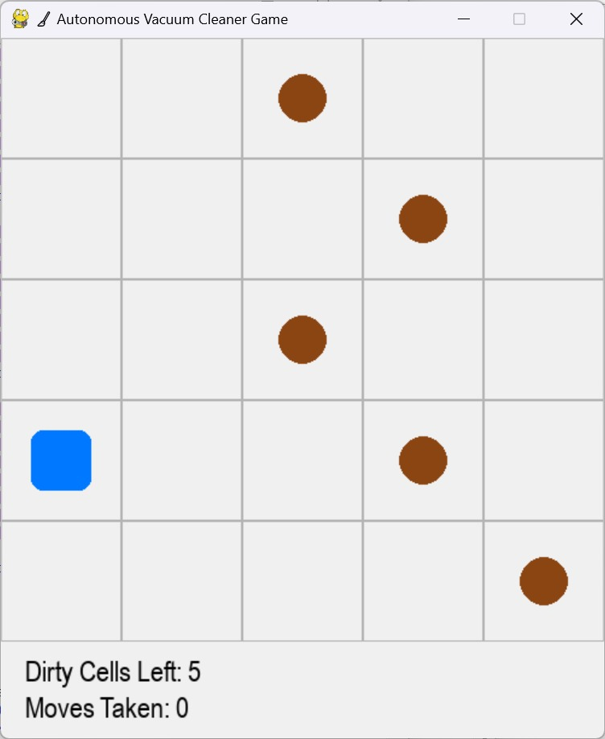
15. Implement a Python program to solve the N-Queens problem using Hill Climbing. The program should:
a) Represent a state as positions of N queens (one per column).
b) Define a cost function = number of attacking pairs of queens.
c) Generate neighbors by moving one queen within its column to a different row.
d) Move to the best neighbor if it strictly improves the cost.
e) Stop when no better neighbor exists (local optimum).
f) (Optional) Use random restarts to increase the chance of finding a global optimum.
g) Print the final board, the final cost, and whether a valid solution (cost = 0) was found.
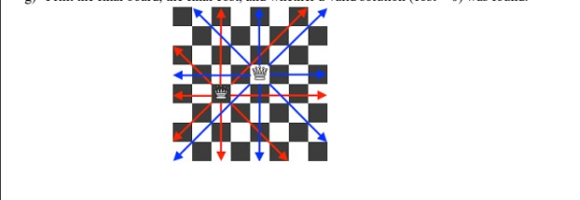
n queens problem using hill climbing
import random

def print_board(state):
n = len(state)
for row in range(n):
line = ""
for col in range(n):
if state[col] == row:
line += "Q "
else:
line += ". "
print(line)
print()

# Cost function: number of attacking pairs
def compute_cost(state):
attacks = 0
n = len(state)
for i in range(n):
for j in range(i + 1, n):
if state[i] == state[j] or abs(state[i] - state[j]) == abs(i - j):
attacks += 1
return attacks

# Generate all neighbors by moving one queen in its column
def get_neighbors(state):
neighbors = []
n = len(state)
for col in range(n):
for row in range(n):
if row != state[col]:
new_state = list(state)
new_state[col] = row
neighbors.append(new_state)
return neighbors

# Hill Climbing Algorithm
def hill_climbing(n, max_restarts=10):
best_overall = None
best_cost = float("inf")

for restart in range(max_restarts):
current = [random.randint(0, n - 1) for _ in range(n)]
current_cost = compute_cost(current)

while True:
neighbors = get_neighbors(current)
neighbor_costs = [compute_cost(neighbor) for neighbor in neighbors]
min_cost = min(neighbor_costs)
if min_cost >= current_cost: # Local optimum
break
best_neighbor = neighbors[neighbor_costs.index(min_cost)]
current, current_cost = best_neighbor, min_cost

# Track the best solution across restarts
if current_cost < best_cost:
best_cost = current_cost
best_overall = current

# If a valid solution is found
if best_cost == 0:
break

print("Final Board:")
print_board(best_overall)
print("Final Cost:", best_cost)
if best_cost == 0:
print("✅ Solution Found!")
else:
print("⚠ Local Optimum Reached.")

# Run the algorithm
n = 8 # You can change N here
hill_climbing(n)

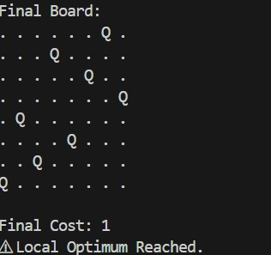
16. You are given a map with regions (represented as nodes or vertices) that need to be colored such that no
adjacent regions have the same color. The goal is to find a valid coloring for the entire map. Implement in
graph using python.
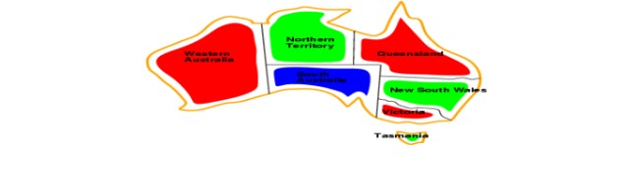
import pygame
import sys
import math

# --- Initialize Pygame ---
pygame.init()
WIDTH, HEIGHT = 800, 600
screen = pygame.display.set_mode((WIDTH, HEIGHT))
pygame.display.set_caption("Map Coloring Game")

FONT = pygame.font.SysFont("arial", 24)
SMALL_FONT = pygame.font.SysFont("arial", 18)

# --- Colors ---
WHITE = (255, 255, 255)
BLACK = (0, 0, 0)
GRAY = (200, 200, 200)
RED = (255, 80, 80)
GREEN = (100, 255, 100)
BLUE = (80, 150, 255)
YELLOW = (255, 255, 100)
COLORS = {"Red": RED, "Green": GREEN, "Blue": BLUE, "Yellow": YELLOW}
color_names = list(COLORS.keys())

# --- Graph (Map) Definition ---
graph = {
'A': ['B', 'C', 'D'],
'B': ['A', 'C', 'E'],
'C': ['A', 'B', 'D', 'E'],
'D': ['A', 'C', 'E'],
'E': ['B', 'C', 'D']
}

# --- Node positions (for drawing) ---
positions = {
'A': (200, 200),
'B': (400, 100),
'C': (400, 300),
'D': (600, 200),
'E': (500, 400)
}

# --- Node colors ---
node_colors = {node: None for node in graph}
selected_color = "Red"

# --- Function to draw the graph ---
def draw_graph():
screen.fill(WHITE)

# Draw edges
for node, neighbors in graph.items():
for neighbor in neighbors:
start = positions[node]
end = positions[neighbor]
pygame.draw.line(screen, BLACK, start, end, 2)

# Draw nodes
for node, (x, y) in positions.items():
color = node_colors[node]
pygame.draw.circle(screen, BLACK, (x, y), 40)
pygame.draw.circle(screen, color if color else GRAY, (x, y), 35)
text = FONT.render(node, True, BLACK)
screen.blit(text, (x - 10, y - 12))

# Draw color palette
pygame.draw.rect(screen, GRAY, (50, 450, 700, 100), border_radius=15)
label = FONT.render("Select Color:", True, BLACK)
screen.blit(label, (60, 460))

for i, cname in enumerate(color_names):
rect = pygame.Rect(220 + i * 120, 460, 60, 60)
pygame.draw.rect(screen, COLORS[cname], rect)
if cname == selected_color:
pygame.draw.rect(screen, BLACK, rect, 4)

txt = SMALL_FONT.render(cname, True, BLACK)
screen.blit(txt, (220 + i * 120, 525))

# Display check result
result_text = check_coloring()
result_label = FONT.render(result_text, True, BLACK)
screen.blit(result_label, (300, 550))

pygame.display.flip()

# --- Check coloring validity ---
def check_coloring():
for node, neighbors in graph.items():
for n in neighbors:
if node_colors[node] and node_colors[n] == node_colors[node]:
return "❌ Invalid Coloring!"
if all(node_colors[n] for n in node_colors):
return "✅ Valid Coloring!"
return "🟡 In Progress..."

# --- Detect if click is inside node ---
def get_clicked_node(pos):
for node, (x, y) in positions.items():
if math.dist(pos, (x, y)) < 40:
return node
return None

# --- Main Loop ---
running = True
while running:
draw_graph()
for event in pygame.event.get():
if event.type == pygame.QUIT:
running = False

# Color selection
if event.type == pygame.MOUSEBUTTONDOWN:
mx, my = event.pos
# Check if clicked on color palette
for i, cname in enumerate(color_names):
rect = pygame.Rect(220 + i * 120, 460, 60, 60)
if rect.collidepoint(mx, my):
selected_color = cname

# Check if clicked on node
node = get_clicked_node((mx, my))
if node:
node_colors[node] = COLORS[selected_color]

pygame.quit()
sys.exit()
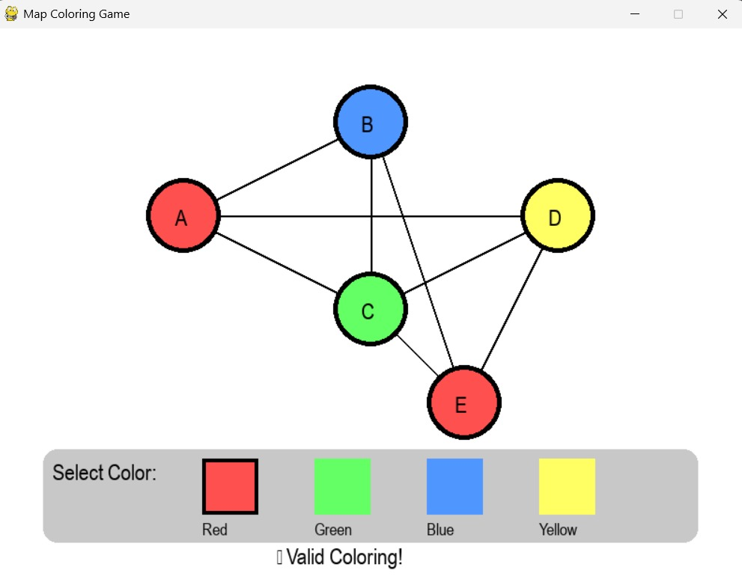
17. Consider a game which has 4 final states and paths to reach final state are from root to 4 leaves of a
perfect binary tree as shown below. Assume you are the maximizing player and you get the first chance
to move, i.e., you are at the root and your opponent at next level. Using python create the program,
which move you would make as a maximizing player considering that your opponent also plays
optimally?
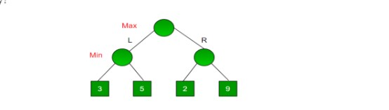
# Minimax Algorithm Example

def minimax(depth, node_index, is_maximizing, values):
"""
Recursive function to apply the minimax algorithm.

depth: current depth in the game tree
node_index: index of the current node
is_maximizing: True if it's the maximizing player's turn, False for minimizing player
values: list of leaf node values
"""
# Base case: if we reach a leaf node
if depth == 2:
return values[node_index]

# If it's the maximizing player's turn
if is_maximizing:
return max(
minimax(depth + 1, node_index * 2, False, values),
minimax(depth + 1, node_index * 2 + 1, False, values)
)
# If it's the minimizing player's turn
else:
return min(
minimax(depth + 1, node_index * 2, True, values),
minimax(depth + 1, node_index * 2 + 1, True, values)
)

# ----------------------------------------------------------
# Leaf nodes (final states)
values = [3, 5, 2, 9]

# Depth of tree = 2 (Root -> Min -> Leaf)
optimal_value = minimax(0, 0, True, values)
print("The optimal value for the maximizing player is:", optimal_value)

# ----------------------------------------------------------
# Determine which move (L or R) the maximizing player should take
left_subtree = min(values[0], values[1]) # Min node under Left
right_subtree = min(values[2], values[3]) # Min node under Right

best_move = "Left" if max(left_subtree, right_subtree) == left_subtree else "Right"
print("The maximizing player should choose:", best_move)
OUTPUT:
The optimal value for the maximizing player is: 3
The maximizing player should choose: Left

18. Implement a Python program to solve a pathfinding problem using the A* algorithm.
The program should:
a) Represent the environment as a graph or a grid with weighted edges.
b) Take a start node and a goal node as inputs.
c) Use a suitable heuristic function (e.g., Manhattan distance for grids, straight-line distance for
graphs).
d) Explore nodes using the A* evaluation function.
e) Print the order of node expansion and the final optimal path with its total cost.
f) Start Node: A Goal Node: F Nodes: A, B, C, D, E, F Edges with weights: (A, B, 1), (A, C, 4),
(B, D, 3), (B, E, 5), (C, F, 2), (D, F, 1), (D, E, 1), (E, F, 2).
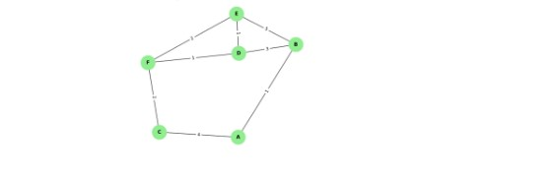
import pygame
import sys
import math
import heapq

# --- Initialize Pygame ---
pygame.init()
WIDTH, HEIGHT = 800, 600
screen = pygame.display.set_mode((WIDTH, HEIGHT))
pygame.display.set_caption("A* Pathfinding Game")

FONT = pygame.font.SysFont("arial", 24)
SMALL_FONT = pygame.font.SysFont("arial", 18)

# --- Colors ---
WHITE = (255, 255, 255)
BLACK = (0, 0, 0)
GRAY = (200, 200, 200)
BLUE = (80, 150, 255)
GREEN = (100, 255, 100)
YELLOW = (255, 255, 100)
ORANGE = (255, 180, 80)
PURPLE = (180, 100, 255)
RED = (255, 80, 80)

# --- Graph Definition ---
graph = {
'A': {'B': 1, 'C': 4},
'B': {'A': 1, 'D': 3, 'E': 5},
'C': {'A': 4, 'F': 2},
'D': {'B': 3, 'E': 1, 'F': 1},
'E': {'B': 5, 'D': 1, 'F': 2},
'F': {'C': 2, 'D': 1, 'E': 2}
}

positions = {
'A': (150, 250),
'B': (300, 150),
'C': (300, 350),
'D': (500, 150),
'E': (500, 350),
'F': (650, 250)
}

start_node = None
goal_node = None

# --- Heuristic ---
def heuristic(n1, n2):
(x1, y1), (x2, y2) = positions[n1], positions[n2]
return math.hypot(x2 - x1, y2 - y1)

# --- A* Algorithm ---
def astar(start, goal):
open_heap = []
heapq.heappush(open_heap, (0, start))
came_from = {}
g_score = {node: float('inf') for node in graph}
g_score[start] = 0
f_score = {node: float('inf') for node in graph}
f_score[start] = heuristic(start, goal)
visited_order = []

while open_heap:
current = heapq.heappop(open_heap)[1]
visited_order.append(current)

if current == goal:
break

for neighbor, weight in graph[current].items():
tentative_g = g_score[current] + weight
if tentative_g < g_score[neighbor]:
came_from[neighbor] = current
g_score[neighbor] = tentative_g
f_score[neighbor] = tentative_g + heuristic(neighbor, goal)
heapq.heappush(open_heap, (f_score[neighbor], neighbor))

path = []
node = goal
if node not in came_from and node != start:
return visited_order, [], float('inf')
while node in came_from:
path.insert(0, node)
node = came_from[node]
path.insert(0, start)
return visited_order, path, g_score[goal]

# --- Draw Graph ---
def draw_graph(visited=set(), path=set()):
screen.fill(WHITE)

# Draw edges
for node, neighbors in graph.items():
for neighbor, weight in neighbors.items():
start_pos = positions[node]
end_pos = positions[neighbor]
pygame.draw.line(screen, GRAY, start_pos, end_pos, 3)
mid_x = (start_pos[0] + end_pos[0]) // 2
mid_y = (start_pos[1] + end_pos[1]) // 2
text = SMALL_FONT.render(str(weight), True, BLACK)
screen.blit(text, (mid_x - 10, mid_y - 10))

# Draw nodes
for node, (x, y) in positions.items():
color = BLUE
if node in visited:
color = YELLOW
if node in path:
color = GREEN
if node == start_node:
color = ORANGE
if node == goal_node:
color = PURPLE
pygame.draw.circle(screen, BLACK, (x, y), 40)
pygame.draw.circle(screen, color, (x, y), 35)
text = FONT.render(node, True, BLACK)
screen.blit(text, (x - 10, y - 12))

# Instructions
instruction = "Click Start Node" if not start_node else \
"Click Goal Node" if not goal_node else "Pathfinding..."
text_inst = FONT.render(instruction, True, RED)
screen.blit(text_inst, (50, 20))

pygame.display.flip()

# --- Detect clicked node ---
def get_clicked_node(pos):
for node, (x, y) in positions.items():
if math.dist(pos, (x, y)) < 40:
return node
return None

# --- Main Loop ---
running = True
visited_order, final_path, cost = [], [], 0
step = 0 # animation step

while running:
draw_graph(set(visited_order[:step]), set(final_path[:step]))
for event in pygame.event.get():
if event.type == pygame.QUIT:
running = False

if event.type == pygame.MOUSEBUTTONDOWN:
clicked = get_clicked_node(event.pos)
if clicked:
if not start_node:
start_node = clicked
elif not goal_node:
goal_node = clicked
visited_order, final_path, cost = astar(start_node, goal_node)
print("Node Expansion Order:", " → ".join(visited_order))
print("Final Path:", " → ".join(final_path))
print(f"Total Cost: {cost}")
step = 0 # reset animation

if start_node and goal_node and step < len(visited_order):
step += 1
pygame.time.delay(500)

pygame.quit()
sys.exit()
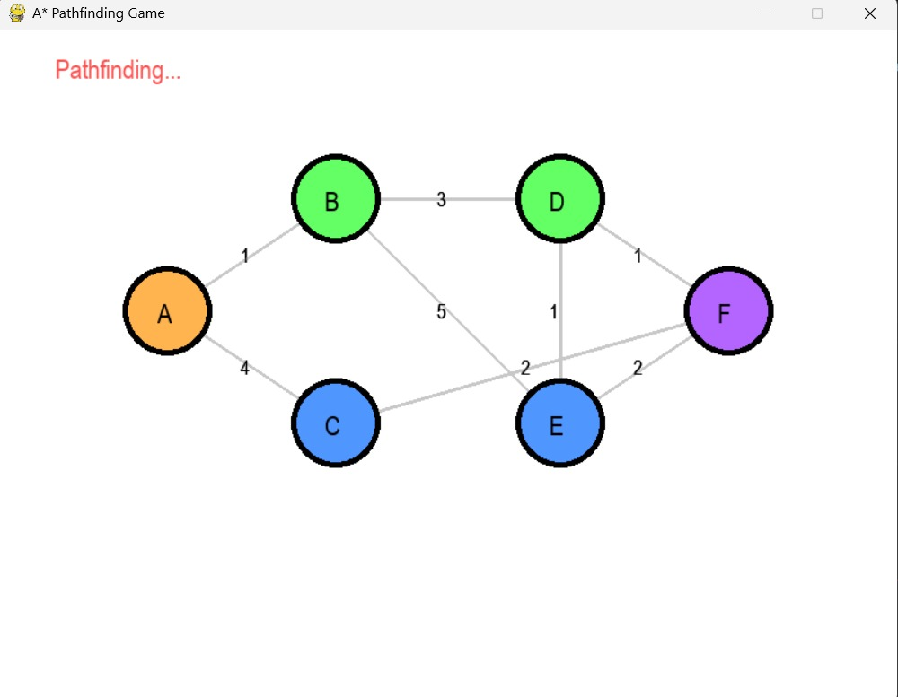

19. Given a list of cities and the distances between each pair of cities, the objective is to find the shortest
possible route that visits each city exactly once and returns to the original city (the salesman's starting
point). Implement the scenario using python.
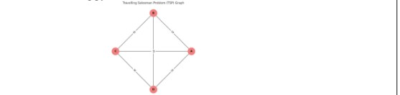
from itertools import permutations
n = int(input("Enter the number of cities: "))
cities = []
for i in range(n):
city = input(f"Enter city name {i + 1}: ")
cities.append(city)
graph = {}
for city in cities:
graph[city] = {}
print("\nEnter the distances between each pair of cities:")
for i in range(n):
for j in range(i + 1, n):
dist = int(input(f"Distance between {cities[i]} and {cities[j]}: "))
graph[cities[i]][cities[j]] = dist
graph[cities[j]][cities[i]] = dist
start = input("\nEnter the starting city: ")
shortest_distance = float('inf')
best_route = []
for perm in permutations([city for city in cities if city != start]):
route = [start] + list(perm) + [start]
distance = 0

for i in range(len(route) - 1):
distance += graph[route[i]][route[i + 1]]

if distance < shortest_distance:
shortest_distance = distance
best_route = route
print("\nShortest Route:", " -> ".join(best_route))
print("Total Distance:", shortest_distance)
OUTPUT:
Enter the number of cities: 4
Enter city name 1: 1
Enter city name 2: 2
Enter city name 3: 3
Enter city name 4: 4

Enter the distances between each pair of cities:
Distance between 1 and 2: 5
Distance between 1 and 3: 9
Distance between 1 and 4: 3
Distance between 2 and 3: 5
Distance between 2 and 4: 10
Distance between 3 and 4: 9

Enter the starting city: 3

Shortest Route: 3 -> 2 -> 1 -> 4 -> 3
Total Distance: 22
20. Implement a Python program to solve a simple scheduling problem using the Simulated Annealing
Algorithm. The program should:
a) Define a set of tasks and available time slots (e.g., 6 tasks, 3 time slots).
b) Represent a schedule as an assignment of tasks to time slots.
c) Define a cost function that penalizes conflicts (e.g., overlapping tasks or exceeding slot capacity).
d) Start with a random schedule and iteratively propose small changes (neighbor solutions).
e) Accept better solutions always; accept worse solutions with probability exp(-ΔE / T) where T is the
temperature.
f) Implement a cooling schedule that gradually decreases temperature.
g) Print the best schedule found and its cost.

#20
import random
import math
import matplotlib.pyplot as plt
import networkx as nx

# -------------------------------
# Problem setup
# -------------------------------

NUM_TASKS = 6
NUM_SLOTS = 3
SLOT_CAPACITY = 2 # each slot can handle 2 tasks at most

tasks = [f"Task{i+1}" for i in range(NUM_TASKS)]
slots = [f"Slot{j+1}" for j in range(NUM_SLOTS)]

# -------------------------------
# Cost function
# -------------------------------

def cost_function(schedule):
"""
Penalizes slot overcapacity and unbalanced distribution.
"""
slot_counts = {s: 0 for s in slots}
for task, assigned_slot in schedule.items():
slot_counts[assigned_slot] += 1

# Penalty for exceeding capacity
penalty = 0
for slot, count in slot_counts.items():
if count > SLOT_CAPACITY:
penalty += (count - SLOT_CAPACITY) * 5 # heavy penalty
# Encourage even distribution (optional)
variance = sum((count - NUM_TASKS / NUM_SLOTS) ** 2 for count in slot_counts.values())
return penalty + variance

# -------------------------------
# Generate random schedule
# -------------------------------

def random_schedule():
return {task: random.choice(slots) for task in tasks}

# -------------------------------
# Get a neighbor solution
# -------------------------------

def neighbor(schedule):
new_schedule = schedule.copy()
# randomly reassign one task
task_to_change = random.choice(tasks)
new_slot = random.choice(slots)
new_schedule[task_to_change] = new_slot
return new_schedule

# -------------------------------
# Simulated Annealing algorithm
# -------------------------------

def simulated_annealing(initial_temp=100.0, cooling_rate=0.95, stop_temp=0.1, iterations_per_temp=100):
current = random_schedule()
current_cost = cost_function(current)
best = current.copy()
best_cost = current_cost
temp = initial_temp
history = []

while temp > stop_temp:
for _ in range(iterations_per_temp):
new = neighbor(current)
new_cost = cost_function(new)
delta = new_cost - current_cost

# Accept if better or with probability exp(-ΔE / T)
if delta < 0 or random.random() < math.exp(-delta / temp):
current, current_cost = new, new_cost
if new_cost < best_cost:
best, best_cost = new.copy(), new_cost

history.append(best_cost)

temp *= cooling_rate # cooling

return best, best_cost, history

# -------------------------------
# Visualization
# -------------------------------

def visualize_schedule(schedule, title="Schedule Visualization"):
G = nx.Graph()
for task, slot in schedule.items():
G.add_node(task, bipartite=0)
G.add_node(slot, bipartite=1)
G.add_edge(task, slot)

plt.figure(figsize=(6, 4))
pos = {{t: (0, i) for i, t in enumerate(tasks)},
**{s: (2, i) for i, s in enumerate(slots)}}
nx.draw(G, pos, with_labels=True, node_size=1500, node_color="lightblue", font_weight="bold", width=1)
plt.title(title)
plt.show()

# -------------------------------
# Main program
# -------------------------------

def main():
print("Simulated Annealing Task Scheduler\n")
best_schedule, best_cost, history = simulated_annealing()

print("✅ Best schedule found:")
for t, s in best_schedule.items():
print(f" {t} → {s}")
print(f"\nFinal Cost: {best_cost:.2f}")

# Plot schedule
visualize_schedule(best_schedule, title="Final Best Schedule")

# Plot cost reduction
plt.figure(figsize=(6, 4))
plt.plot(history)
plt.title("Cost Reduction Over Time")
plt.xlabel("Iteration")
plt.ylabel("Cost")
plt.grid(True)
plt.show()

if _name_ == "_main_":
main()
